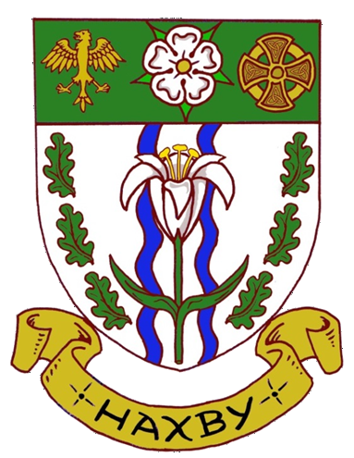 | HAXBY TOWN COUNCIL  Council Office, The Memorial Hall, The Village, Haxby, York YO32 3HT  Tel: 01904 750378 Email: office@haxbytowncouncil.gov.uk
GRANT APPLICATION FORM
For Local Clubs and Community Organisations
Please complete this form as clearly as possible, with any supporting information where necessary and return
it to Haxby Town Council at the above address. Please also refer to the Terms and Conditions below.
1. Name of the Club or Organisation:

Charity Registration No. (if applicable)
Chairman: |  | Secretary or Treasurer:
Address: |  | Address:
Telephone Number(s): |  | Telephone Number(s):
Email address: |  | Email address:
2. Purpose of the Club or Organisation:

3. Purpose for which the Grant will be used: (Use a Continuation Sheet if necessary)

4. Total cost of the Project: (Itemise where possible and if necessary use a Continuation Sheet)

5. Amount of Grant requested:

6. Details of any Grants awarded to your Club/Organisation by Haxby Town Council in the last five years:

7. What percentage of your membership are Haxby residents? %
8. The Council may want to discuss your Application with your representatives so, please supply details of two representatives who will be willing to attend a meeting with nominated Councillors and Council Officers.
Representative 1. |  |  | Representative 2.
Name: |  |  | Name:
Address: |  |  | Address:
Telephone No: |  |  | Telephone No:
9. Form prepared by: |  |  | Sign: | Date:

Terms and Conditions:
- The contribution of a Haxby Town Council Grant must be publically acknowledged by the club/organisation.
- Successful applicants MUST provide a timely and tangible feedback to Haxby Town Council of the
‘What, How, Who and When’ the Grant was spent, outlining the benefits to its members and/or other residents of the Haxby community.

